DoDAF 2.0 -- How to Model Projects

PV-01 Project Portfolio Relationships
The PV-01 viewpoint describes the breakdown of Projects into Sub Projects, and the dependency relationships between organizations and the Projects they own, and the organizational structures needed to manage a portfolio of projects.

Using the Diagram to Build the Model
The PV-01 Project Portfolio Relationships diagram is a data centric, hierarchically built diagram. It enables the following relationships to be created:
- You may attach a Project to a parent Project by moving it under the parent Project until a connection line appears, auto-connecting the Project to the parent Project. Once you do so, the definition of the parent Project will have its Project Has Subprojects property of its Hierarchy tab automatically filled in appropriately, and the definition of the child Project will have its Project Part of Project property automatically filled in appropriately.
- You may attach a Project (and its hierarchy) to its owning Organization by moving the Project under the owning Organization symbol until a connection line appears, auto-connecting the Project (and its hierarchy) to the owning Organization. Once you do so, the definition of the owning Organization's Organization Owns Projects property in its Projects tab will be automatically filled in appropriately, and the definition of the owned Project will have its Project Owned by Organization property in its Organization tab filled in appropriately.

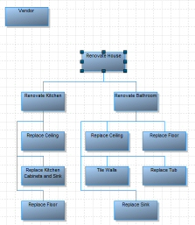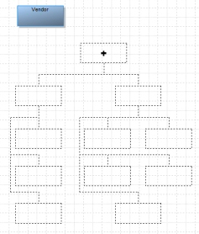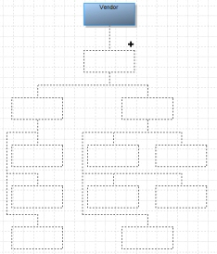
Creating a hierarchy on the PV-1 diagram: Select ONE symbol and move it and its underlying hierarchy underneath another symbol to form the new hierarchy. In this case, a Project (and all its Sub Projects) is moved underneath an Organizational Unit, and auto-attached. You may also move Projects underneath each other to attach in a hierarchy on the PV-1 diagram. To model Organizations in a hierarchy, use the OV-4 diagram.

Using the Definitions to Build the Model -- Auto Visualizing the Diagram
Further, you may relate the Projects to their owning Projects or sub Projects or owning Organizations within the appropriate definition properties (as stated above), and drag and drop the Project definitions onto the PV-1 diagram -- the diagram and the hierarchical relationships will draw themselves.

PV-01 Project Portfolio Relationships At Time
The PV-01 Project Portfolio Relationships At Time diagram is a non-data centric diagram that allows you to model Projects and their Hierarchy, and the Organizations that own them at a particular Milestone, or point in time. The Milestone is related to the diagram in the properties of the diagram.

Relationships that you form on this diagram do not effect the properties of the definitions on a global basis throughout the repository. This enables you to sketch out Projects and their owning Organizations without committing the changes to a global view.

PV-02 Project Timelines
A Project is a plan or scheme for a task that takes place over a period of time. It contains Milestones. The PV-2 Project Timelines diagram enables you to visualize a program or portfolio of Projects and their Milestones based on a timeline. You may also visualize interdependencies of Projects.
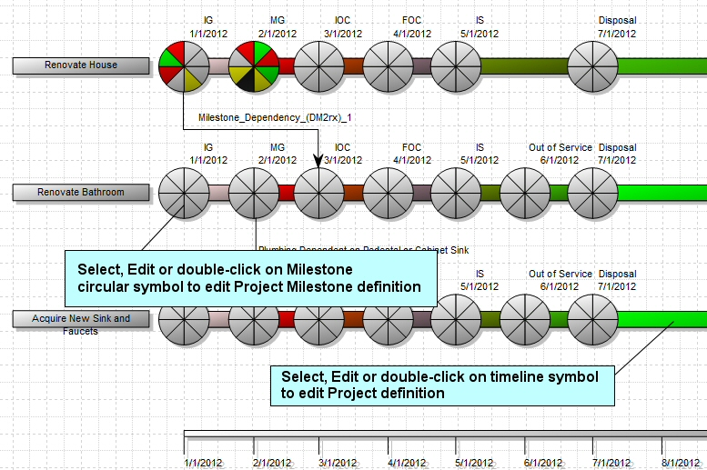
You may specify that the Project tracks or does the following:
- Desired Effect(s) of the Project -- Desired Effect is a primary definition type in DoDAF 2. You may specify the Desired Effect of a Project on page 2 of the DoDAF 2 tab of the Project definition. The Desired Effect definition must be created first, then dragged into the Project definition's Desired Effect field using the Choices button.
  - Example: A Desired Effect of the Project to "Renovate Kitchen" is "Modernize Kitchen So House Can Be Rented".
- Activities that are performed during the Project.
- Capabilities that the Project enables at Each Milestone -- you may specify the Capabilities that the Project enables at each Project Milestone. This is done in the Capability definition, within the CV-3 tab -- click on Choices and populate the Capability Increments property with the Milestone at which it is enabled. (If you right-mouse click anywhere in the Select and Drag dialog and click on Details, you can see the Project that each Milestone is associated with in the Details window.)
- Hierarchy of Projects -- You can specify whether the Project has Sub Projects, or is itself a Sub Project reporting to a Parent Project. This is done either in the Hierarchy tab of the definition of a Project or by visualizing/creating/editing the hierarchy on the PV-1 Project Portfolio Relationships diagram.
- In the Hierarchy tab of the Project definition, you may specify that the Project is part of a higher-level Project in the Part of Project property. The parent Project must be already created in the repository; you click on Choices to drag it into the field.
- You may specify that a Project has sub Projects in the Project Has Sub Projects field of the Hierarchy tab of the Project definition. You may automatically visualize the hierarchy of projects by dragging them onto the PV-1 Project Portfolio Relationships diagram. You may also use the diagram to place projects in a hierarchy (thereby editing the appropriate project definitions).
- Who owns the Project -- you may specify the Organization or Person that own the Project in the Organization tab of the Project definition.
- Described By -- this property enables you to provide a description of the Project through a reusable set of Information definitions. You must create the Information definition first, via the Explorer (Browser), and then drag it into the Project definition. The alternative is to use the Description textual property of the Project definition.
- Measures -- you may specify Measures for the Project. You must create the Measure definition first (and any of its subtypes) via the Explorer (Browser) and then drag and drop the Measure definition into the Project definition.
Note: You may edit the Project timeline symbol by selecting to edit (or double-clicking on) its horizontal bar symbol. You may edit the Milestone of a Project timeline symbol by selecting to edit (or double-clicking on) its circle symbol.
You may also draw Dependency lines between Milestones of different projects, thereby modeling the interdependencies between the Project stages.

Project Milestones
Milestones are represented as circles positioned on the project’s timeline bar. Each Milestone circle is divided into sections so that it resembles a pie. Each section of the Milestone 'pie' represents a particular Project Thread that you are tracking, such as Equipment, Logistics, Infrastructure, Organization, Doctrine, Information, Personal, and Training. The color of the pie section represents the status of that particular Project Thread at that Milestone, as specified later on this page.
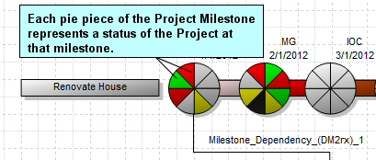

Default Set of Project Milestones
For DoDAF 2, System Architect provides a standard set of Milestones which you can change (described later on this page). The standard set of Milestones is as follows:
- IG (Initial Gate)
- MG (Main Gate)
- IOC (Initial Operational Capability): The first attainment of the capability to employ effectively a weapon, item of equipment, or system of approved specific characteristics, and which is manned and operated by an adequately trained, equipped, and supported military force or unit.
- FOC (Full Operational Capability): Full capability to employ effectively a weapon, item of equipment, or system of approved specific characteristics, and which is manned and operated by an adequately trained, equipped, and supported military force or unit.
- IS (In Service)
- Out of Service
- Disposal

Creating Your Own Standard Set of Default Milestones for Projects
You may create your own set of Milestones for any Project. You may also set up a standard set of Milestones so that all new Projects that you add to a diagram automatically have the standard set. This is accomplished through use of the "Model Project" specified for an encyclopedia, within the Project definition set. All DoDAF 2 encyclopedias are prepopulated with a Project definition named "Model Project", and this project has the default set of Milestones. If you change the Milestones in this definition, then all new Projects will have your default set of Milestones through inheritance -- the milestones specified in this ‘Model Project' become the default milestone set for all new Projects drawn on a PV-2 diagram (if there are no existing Projects on the diagram).
- In the Definitions grouping of the Rational System Architect Explorer (Browser) of a DoDAF 2 encyclopedia, navigate to the Project definition.
- Notice that there is a Project named Model Project. This definition instance is loaded into the encyclopedia upon creation of any DoDAF 2 encyclopedia.
- Open the Model Project.
- Either leave the standard set of Milestones, or add your own.
Milestones filtered by topmost project, phase colors come from settings in topmost project: this setting may be set in the PV-02 diagram properties. When toggled on, it causes the following behavior: If there is at least one Project already drawn on an PV-2 diagram, then any additional new Projects drawn on the diagram will contain Milestones as specified in the top-most Project on the diagram.

Projects dragged onto a diagram from the Explorer (Browser) will display the Milestones contained in their definition – not the ones specified in the Model Project template definition, or the ones on the top-most Project on the diagram. Therefore, you may create a diagram that has a heterogeneous group of Project definitions.

Running Rules Checks for Creation of Milestones
Rules checks can be run to make sure that the Milestones on the diagram are in correct chronologic order based on their Milestone Date property (for example, Stage_2 always comes after Stage_1, and Stage_3 always comes after Stage_2, etc). You may run the Rules Check manually by selecting Reports, Rules Check.
You have the following options available for Rules Checks for the PV-2 diagram, available in the Behavior tab of the diagram's property dialog (either select Edit, Diagram Properties with the PV-2 diagram open, or right-mouse click on the diagram workspace and select Diagram Properties):
- Base rules check on topmost project - Rules checks are run to make sure that the Milestones on the diagram are in correct chronologic order based on their Milestone Date property. The Rules Check can be based on the "Model Project" or on the top-most Project on a diagram. To specify that the rules check be based on the top-most Project on a diagram, toggle this property on. Rules checks for new diagrams are based on the Model Project unless you toggle on this option.
- Run rules check automatically - As mentioned above, you may run the Rules Check manually by selecting Reports, Rules Check. If you toggle on the Run rules check automatically option, the Rules Check will run automatically when you open a diagram or draw symbols on it.

Milestone Types and Status
Each Milestone of a Project tracks the following threads:
- Equipment
- Logistics
- Infrastructure
- Organization
- Doctrine
- Information
- Personnel
- Training
You may specify the status of each of these threads for each Milestone on the Project Threads tab of the Milestone definition. Each status of a Milestone thread is represented on the Milestone pie-chart symbol by the following colors:
Milestone Types and Status Colors
- Not Specified -- White
- No Outstanding Issues -- Green
- Manageable Issues -- Yellow
- Critical Issues -- Red
- Not Known -- White
- Not Required -- Black
You may change these colors, and add new ones, by adjusting the metamodel via usrprops.txt. You may specify up to a maximum of eight statuses. For the out-of-box property set for this diagram, see C:\Program Files (x86)\IBM\Rational\System Architect Suite\System Architect\Property Set\dodaf2_pv2.cfg.

Filtering the Milestones Appearing on a Diagram
You are allowed to place Projects that have a disparate set of Milestones on a diagram. If you want to view these projects in terms of their common Milestones, toggle on the Diagram property named Milestones filtered by topmost project, phase colors come from settings in topmost project. To do this, perform the following steps:
- Open the diagram's property dialog (either select Edit, Diagram Properties with the PV-2 diagram open, or right-mouse click on the diagram workspace and select Diagram Properties).
- In the Behavior tab, toggle on the following setting: Milestones filtered by topmost project, phase colors come from settings in topmost project.
With this setting turned on, only the Milestones that exist in the top-most Project on the diagram will be displayed within all of the Projects on the diagram. Also, the in-between-Milestone phase colors for all Projects will also abide by what is set in the top-most Project.
Specifically, with this property set, all Milestones take their Following Color value from the common Milestones on the top-most Project. For example, let’s say you have two Projects on a diagram –Project_1 and Project_2, where Project_1 is the top-most project. Each Project has a Milestone named Stage_1. The Following Color property of Stage_1 Milestone on Project_1 is set to red, and the Following Color property of Stage_1 Milestone on Project_2 is set to blue. If you toggle this property on, then on the diagram, the color of the Project line after the Stage_1 Milestone on Acquisition Project_2 will be red (not blue).
Also, with this property set, all Projects take their Pre-First Milestone Color from the top-most project. So if the Pre-First Milestone Color property for Project_1 is green, and the Pre-First Milestone Color property for Project_2 is black, then on the diagram both Project lines will have a green color before their Stage_1 Milestone.

Setting Pink as the Default Color for the Pre-First Milestone
You may set the color of the Project timeline appearing before the first milestone to default to pink.
- Open the diagram's property dialog (either select Edit, Diagram Properties with the AcV-2 diagram open, or right-mouse click on the diagram workspace and select Diagram Properties).
- In the Behavior tab, toggle on the following setting: Use pink as the default only for the pre-first milestone color when not filtering.
Toggling this option on sets pink as the color of the Acquisition Project line before the first milestone, unless you have set a color in the Pre-first Milestone Color property in the Acquisition Project definition. This toggle choice is overridden if you have toggled on the Milestones filtered by topmost project… property.

Adding a Key Symbol (or Legend) to the Diagram
You may select the Key tool from the toolbar and place one on a PV-2 diagram. The Key symbol provides the Legend describing the color coding used for Milestones and Phases. The Key (or Legend) is automatically based on all milestones in all projects on the diagram. Color codes for Milestone Project Thread Status can only be changed by altering the metamodel via usrprops.txt.

Milestone Dependency Line
You can use the Milestone Dependency line to indicate the direction of the flow of data as it moves from one point in the system to another.
Note: You may attach a diagram to a Milestone symbol as a 'child' diagram through normal Rational System Architect procedures. The child-diagram indicator is placed over the name of the Milestone (not to the upper left-hand corner as is normally done). This is because the name of a Milestone is forced to be outside the Milestone pie-chart symbol; it cannot be made to be inside the symbol.

Timeline
A Timeline symbol is automatically drawn once a PV-2 diagram has been created. The Timeline indicates the period over which the Project development is shown. The following properties apply:
- Start Date
- End Date
- Interval Number
- Interval Units displayed as : Day, Month, Quarter, Week, and Year.
You may edit the Timeline through normal definition editing techniques -- double-clicking on the Timeline symbol on the diagram, right-mouse clicking on the symbol and choosing Edit Timeline, or selecting the symbol and choosing Edit, Edit Timeline from the main menu.

PV-3
The PV-3 is a report that generates all Projects, a description of each Project, and the Capabilities that it enables.

The PV-3 report is run by doing the following:
- Select Reports, Report Generator. The Reports dialog will open. You need to be in the DAF2.rpt file -- the top of the dialog specifies what report file you are in.
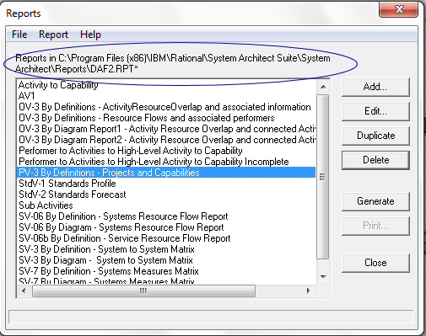
- If you are not in DAF2.rpt, do the following -- select File, Open Report File, and in the Report File Selection dialog, select DAF2.rpt.
- In the Reports dialog, select PV-3 By Definitions -- Projects and Capabilities and press Generate (or simply double click on the report).

You may of course click Edit and adjust the out-of-box report, by adding additional properties for to publish for a Project. Below is a custom PV-3 report, which shows Projects, their Milestones, and the Capabilities enabled at each Milestone -- in our example, a new shower is added to a bathroom renovation to enable the capability "Take Shower".
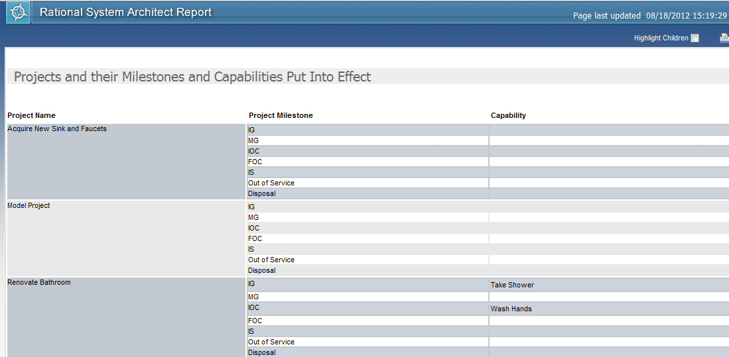

The report above utilizes the "Partial" command at the upper-most layer -- in the Properties to Print for Project, the Partial command was toggled on, so that all Milestones for every Project are output to the report, and then the Capabilities enabled at each Milestone of a Project.

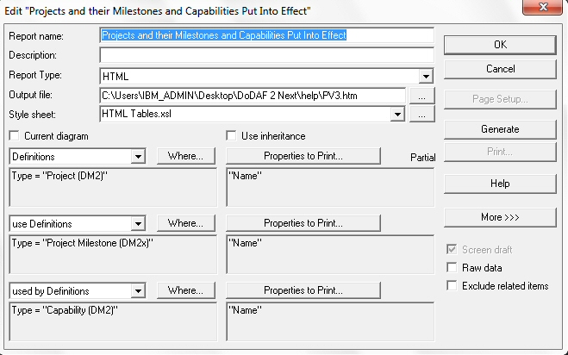

CV-03 -- Generating the Capability Phasing Report
The CV-03 shows the planned achievement of capability at different points in time or during specific periods of time. The CV-3 shows the capability phasing as activities, conditions, desired effects, rules complied with, resource consumption, production, and measures. It does so without regard to the performer and location solutions.

The CV-3 report can be used to assist in the identification of:
- capability shortfalls (no fielded capability to fulfill a particular function) or
- capability duplication (multiple fielded capabilities for a single function).

The CV-03 report, output to Excel, provides a roadmap of Capabilities that are fielded over time, and the name of the Project Milestone at which the Capability is fielded. It also colors the cell containing the Project Milestone with the color that signifies that phase of the Project -- the color is specified on the Phase tab of the Project Milestone's definition, in the Following Color property. An empty cell signifies that a Project Milestone is not associated with a Capability,
The example CV-03 report above was generated from the PV-2 data shown below:
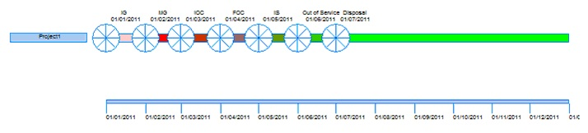
In Project1, each milestone is associated with the Capability Take Pictures, except for the 'Out of Service’ milestone, which causes that milestone to not be generated to the CV-03 report, causing a gap to appear.

In such a scenario:
- No sorting is applied to milestones, if more than one milestone is placed in an interval cell.
- All milestones which match, or are later than a time interval and before the following time interval, are listed within that interval.
- The cell color is set to the following color of the first milestone that matches the interval (if more than one milestone is placed in a time interval).
- Gaps are shown where a project milestone associated with an interval are not assigned to the capability.

Before you begin
To be able to generate the CV-3 report, you must first relate one or more Capabilities to the Project Milestone(s) each is achieved at, as follows:
- Create one or more Capability (DM2) definitions.
- Create one or more Projects with Milestones -- this is done by creating one or more Project (DM2) definitions in the Explorer (browser) or by modeling them on PV-01 or PV-02 diagrams.
- Relate a Capability to the Project Milestone(s) it is achieved at -- on the CV-03 tab of the Capability (DM2) definition, click on the Choices button (see Important Note below) and drag-and-drop the Project Milesone(s) into the Capability Increments grid. You are saying that at this point in the Project, this Capability becomes available.
  - Important Note: In the Select and Drag dialog for Project Milestones, right-mouse click and select Details. You will see a summary of each Milestone that you select in the dialog, and can view its Project at the top of the Details dialog.
- If you wish to change the Milestone Date while in the Capability definition, select the Capability in the Capability Increment grid, and click the Define button (you cannot change the date in the read-only grid).

Procedure
In Rational System Architect, you generate the CV-03 as a report, as follows:
- Click the Reports menu and select DoDAF2 Reports> CV-03 Capability Phasing Report.
- Specify the Start date, End date, Timescale units ,and Interval.
- Click OK. The report is automatically generated to Microsoft Excel.
Tip: If the report is empty ensure that Project Milestones are assigned to the capabilities. See Before You Begin section above.

Results
The Capability Phasing Report opens in a Microsoft Excel Spread sheet. The report contains the name of each Resource related to a Capability in the appropriate cells of the spreadsheet, per each Milestone Date of its related Acquisition Project. Each cell is colored with the Following Color property of each milestone.

